Woordenschat unit 2 (1e editie) en unit 5 (2e editie)
A/ Choose the correct translation.
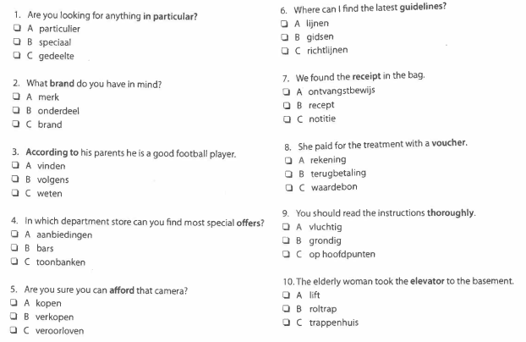
B/ Match the opposites.
1. responsible a. next
2. previous b. exclude
3. extend c. irresponsible
4. possible d. be absent
5. attend e. worthless
6. include f. impossible
7. valuable g. reduce

C/ Use the words from the box to complete the sentences.
event postpone message complaint useful celebrate solution unfortunately

1. I’m afraid I have to __________________ the appointment tomorrow. I’m too busy. Can we meet next week?
2. Don’t worry. I’m sure we’ll find a __________________ to this problem.
3. Excuse me, sir. I have a __________________ about your service. Could I speak to the manager?
4. I’m turning 18. Let’s __________________ ! I want a big party.
5. I know everything about the company so I can give you some __________________ information. What do you want to know?
6. The festival turned out to be a huge cultural __________________.
7. I’ve just got a __________________ from a friend of mine. He’s getting married next month.
8. __________________ , our dream holiday was a disaster. Everything went wrong.
D/ Translate the words in brackets.
1. Can I (voorstellen) __________________ something?
2. I look forward to your (reactie) __________________ .
3. Can you (uitleggen) __________________ what’s just happened?
4. You (lijkt) __________________ extremely upset today. What’s the matter?
5. If you wish to (inschrijven) __________________ , please visit our website and fill in a form.
6. You have (besteld) __________________ two dozens of the BCD model. Can you (bevestigen) __________________ this?
7. You cannot (binnenkomen) __________________ the building after 6p.m.
8. I’m going to (vrijwilligerswerk doen) __________________ for two afternoons a week.
9. I’ve made a double appointment. I’ll have to (afzeggen) __________________ one.
10. Who do you want to (uitnodigen) __________________ to your wedding reception?

